Asimov, Young Monsters, Harper & Row 1985 First Edition, First Print full line, Ex-Libris library binding. Very good, unclipped dust jacket, price $11.89 in mylar and separated from the book and tape removed. Library tag on jacket spine. Very good hardcover with all 213 pages tightly bound with no marks in the text. Library pocket on first page after interior front cover and stamp on title page. Tape marks on front and back pages. Cover art Fred Marcellino ISBN 0060201703

ID 000344 Price $35 Box 7
Ebay $40.50
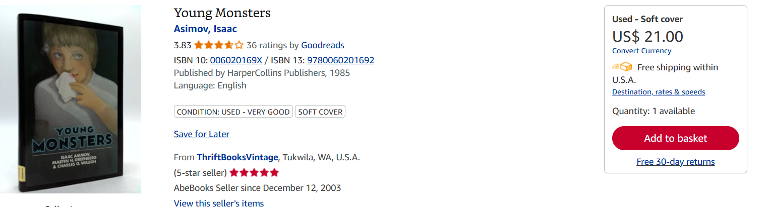
AbeBooks has only soft cover. $9 to $21 to new $105

